

# 

### Semester Two Examination, 2018

### Question/Answer booklet

# MATHEMATICS

**SOLUTIONS**

**METHODS**

**UNITS 1 AND 2**

## Section One:

## Calculator-free

|  |  |  |  |  |  |  |  |  |  |  |
| --- | --- | --- | --- | --- | --- | --- | --- | --- | --- | --- |
| Student number: In figures |  |  |  |  |  |  |  |  |  |  |

In words

Your name

## Time allowed for this section

Reading time before commencing work: five minutes

Working time: fifty minutes

## Materials required/recommended for this section

***To be provided by the supervisor***

This Question/Answer booklet

Formula sheet

***To be provided by the candidate***

Standard items: pens (blue/black preferred), pencils (including coloured), sharpener,  
correction fluid/tape, eraser, ruler, highlighters

Special items: nil

## Important note to candidates

No other items may be taken into the examination room. It is **your** responsibility to ensure that you do not have any unauthorised material. If you have any unauthorised material with you, hand it to the supervisor **before** reading any further.

## Structure of this paper

|  |  |  |  |  |  |
| --- | --- | --- | --- | --- | --- |
| Section | Number of questions available | Number of questions to be answered | Working  time (minutes) | Marks available | Percentage of examination |
| Section One:  Calculator-free | 8 | 8 | 50 | 52 | 35 |
| Section Two:  Calculator-assumed | 13 | 13 | 100 | 98 | 65 |
|  | | |  | **Total** | 100 |

## Instructions to candidates

1. The rules for the conduct of examinations are detailed in the school handbook. Sitting this examination implies that you agree to abide by these rules.

2. Write your answers in this Question/Answer booklet.

3. You must be careful to confine your response to the specific question asked and to follow any instructions that are specified to a particular question.

4. Supplementary pages for the use of planning/continuing your answer to a question  
have been provided at the end of this Question/Answer booklet. If you use these pages to continue an answer, indicate at the original answer where the answer is continued, i.e. give the page number.

5. Show all your working clearly. Your working should be in sufficient detail to allow your answers to be checked readily and for marks to be awarded for reasoning. Incorrect answers given without supporting reasoning cannot be allocated any marks. For any question or part question worth more than two marks, valid working or justification is required to receive full marks. If you repeat any question, ensure that you cancel the answer you do not wish to have marked.

6. It is recommended that you do not use pencil, except in diagrams.

7. The Formula sheet is not to be handed in with your Question/Answer booklet.

Section One: Calculator-free 35% (52 Marks)

This section has**eight (****8)** questions. Answer **all** questions. Write your answers in the spaces provided.

Working time: 50 minutes.

Question 1 (4 marks)

(a) Expand ${\left(2x+1\right)}^{3}$. (2 marks)

|  |
| --- |
| **Solution** |
| $${\left(2x+1\right)}^{3}=\left(1\right){\left(2x\right)}^{3}{\left(1\right)}^{0}+\left(3\right){\left(2x\right)}^{2}{\left(1\right)}^{1}+\left(3\right){\left(2x\right)}^{1}{\left(1\right)}^{2}+\left(1\right){\left(2x\right)}^{0}{\left(1\right)}^{3} \\ =8x^{3}+12x^{2}+6x+1$$ |
| **Specific behaviours** |
| ✓ correct method  ✓ correct expansion |

(b) Determine the gradient of the curve $y={\left(2x+1\right)}^{3}$ at the point $(1, 27)$. (2 marks)

|  |
| --- |
| **Solution** |
| $$\frac{dy}{dx}=24x^{2}+24x+6$$ $$x=1⇒\frac{dy}{dx}=24+24+6=54$$ |
| **Specific behaviours** |
| ✓ differentiates expression from (a)  ✓ evaluates gradient |

Question 2 (6 marks)

(a) Evaluate $\begin{matrix}m^{2} \\ \overline{n^{0.5}}\end{matrix}$ when $m=6×{10}^{2}$ and $n=9×{10}^{4}$, writing your answer without the use of scientific notation. (3 marks)

|  |
| --- |
| **Solution** |
| $$\frac{m^{2}}{n^{0.5}}=\frac{6^{2}×{10}^{4}}{\sqrt{9}×{10}^{2}} \\ =\frac{36}{3}×{10}^{2} \\ =1 200$$ |
| **Specific behaviours** |
| ✓ simplifies $m^{2}$ ✓ simplifies $n^{0.5}$ ✓ correct value |

(b) Determine the value of $x$ when $9^{x}=27\sqrt{3}$. (3 marks)

|  |
| --- |
| **Solution** |
| $$3^{2x}=3^{3}×3^{\frac{1}{2}}$$ $$=3^{\frac{7}{2}}$$ $$2x=\frac{7}{2}⇒x=\frac{7}{4}$$ |
| **Specific behaviours** |
| ✓ LHS as power of 3  ✓ RHS as power of 3  ✓ equates indices and solves |

Question 3 (7 marks)

Solve each equation below for $x$.

(a) $\begin{matrix}3x \\ \overline{x-5}\end{matrix}=\begin{matrix}2 \\ \overline{3}\end{matrix}$. (2 marks)

|  |
| --- |
| **Solution** |
| $$9x=2x-10 \\ 7x=-10 \\ x=-\frac{10}{7}$$ |
| **Specific behaviours** |
| ✓ cross multiplies  ✓ correct solution |

(b) $\left(x+3\right)\left(x-3\right)=8x$. (3 marks)

|  |
| --- |
| **Solution** |
| $$x^{2}-9=8x \\ x^{2}-8x-9=0 \\ \left(x+1\right)\left(x-9\right)=0 \\ x=-1, x=9$$ |
| **Specific behaviours** |
| ✓ expands and equates to zero  ✓ factorises  ✓ correct solutions |

(c) $\sqrt{2}\sin{x}+1=0, 0°≤x≤360°$. (2 marks)

|  |
| --- |
| **Solution** |
| $$\sin{x}=-\frac{1}{\sqrt{2}}$$ $$x=225°, x=315°$$ |
| **Specific behaviours** |
| ✓ one correct solution  ✓ both correct solutions |

Question 4 (7 marks)

(a) Simplify

(i) $\begin{matrix}d \\ \overline{dx}\end{matrix}(10-3x+4x^{2})$. (1 mark)

|  |
| --- |
| **Solution** |
| $$-3+8x$$ |
| **Specific behaviours** |
| ✓ correct derivative |

(ii) $\lim_{h→0}{\begin{matrix}{\left(x+h\right)}^{2}-x^{2} \\ \overline{ h }\end{matrix}}$. (1 mark)

|  |
| --- |
| **Solution** |
| $$2x$$ |
| **Specific behaviours** |
| ✓ correct derivative |

(b) Determine the equation of the tangent to the curve $y=x^{3}-9x+15$ when $x=2$.

(3 marks)

|  |
| --- |
| **Solution** |
| $$\frac{dy}{dx}=3x^{2}-9$$ $$x=2, y=8-18+15=5, \frac{dy}{dx}=12-9=3$$ $$y-5=3\left(x-2\right)⇒y=3x-1$$ |
| **Specific behaviours** |
| ✓ correct derivative  ✓ calculates $y$-coordinate and gradient  ✓ correct equation of tangent, in any form |

(c) Determine $f(x)$ given $f^{'}\left(x\right)=6x-2$ and $f\left(-1\right)=6$. (2 marks)

|  |
| --- |
| **Solution** |
| $$f\left(x\right)=3x^{2}-2x+c$$ $$3{\left(-1\right)}^{2}-2\left(-1\right)+c=6⇒c=1$$ $$f\left(x\right)=3x^{2}-2x+1$$ |
| **Specific behaviours** |
| ✓ correct antiderivative with constant  ✓ correct $f(x)$ |

Question 5 (6 marks)

A small body moves in a straight line so that its displacement $x$ from a fixed point $O$ after $t$ seconds is given by $x=at^{2}+bt+c$ metres.

The position-time graph of the body is shown below.

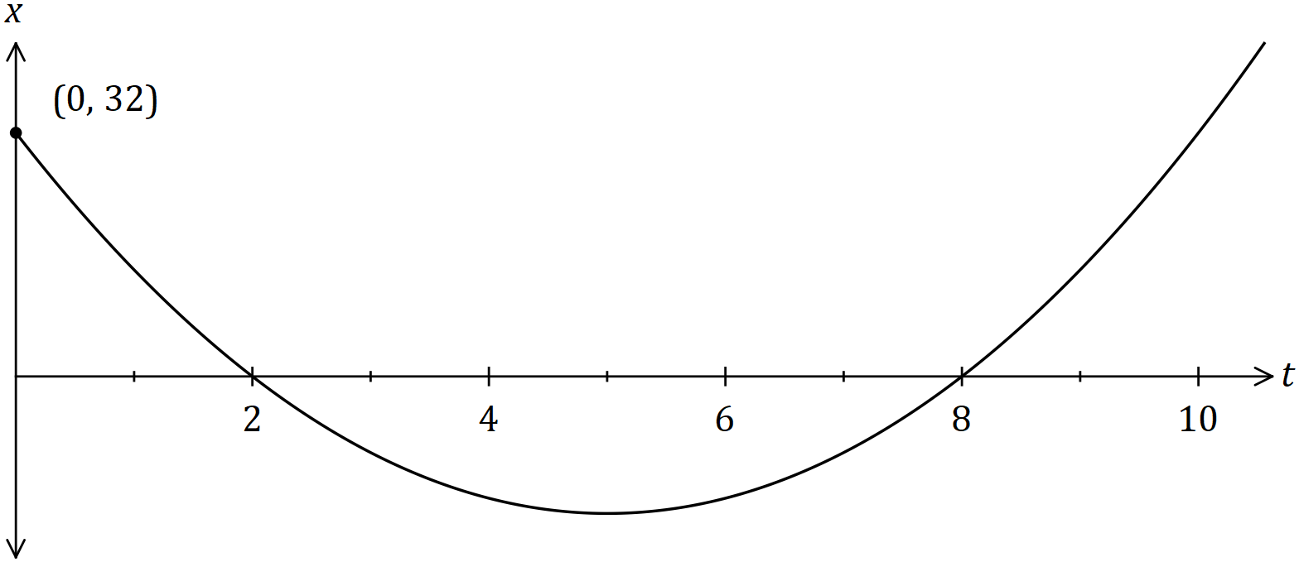

(a) Determine the values of the constants $a, b$ and $c$. (3 marks)

|  |
| --- |
| **Solution** |
| $$x=a\left(t-2\right)\left(t-8\right)$$ $$32=a\left(-2\right)\left(-8\right)⇒a=2$$ $$x=2\left(t^{2}-10t+16\right) \\ =2t^{2}-20t+32$$ $$a=2, b=-20, c=32$$ |
| **Specific behaviours** |
| ✓ writes equation using roots  ✓ uses $y$-intercept to find $a$ ✓ expands and states three values |

(b) Determine the displacement of the body when its velocity is ms-1. (3 marks)

|  |
| --- |
| **Solution** |
| $$v=4t-20$$ $$4t-20=24⇒t=11$$ $$x\left(11\right)=2\left(11-2\right)\left(11-8\right)=54 \text{m}$$ |
| **Specific behaviours** |
| ✓ equation for velocity  ✓ solves for time  ✓ substitutes for displacement |

Question 6 (6 marks)

The derivative of a cubic polynomial is given by $\begin{matrix}dy \\ \overline{dx}\end{matrix}=3x^{2}+6x-10$.

The cubic passes through the point $(1, -30)$.

(a) Determine the equation of the cubic. (2 marks)

|  |
| --- |
| **Solution** |
| $$y=x^{3}+3x^{2}-10x+c$$ $$-30=1+3-10+c⇒c=-24$$ $$y=x^{3}+3x^{2}-10x-24$$ |
| **Specific behaviours** |
| ✓ antidifferentiates correctly  ✓ determines constant |

(b) Show that the cubic has a root when $x=3$. (1 mark)

|  |
| --- |
| **Solution** |
| $$x=3, y=27+27-30-24=54-54=0$$ |
| **Specific behaviours** |
| ✓ substitutes and obtains zero |

(c) Determine the coordinates of the other two roots of the cubic. (3 marks)

|  |
| --- |
| **Solution** |
| $$x^{3}+3x^{2}-10x-24=\left(x-3\right)\left(x^{2}+ax+8\right) \\ =\left(x-3\right)\left(x^{2}+6x+8\right) \\ =\left(x-3\right)\left(x+4\right)\left(x+2\right)$$ $$\text{Other roots at} \left(-2, 0\right)\text{ and} \left(-4, 0\right).$$ |
| **Specific behaviours** |
| ✓ obtains quadratic factor by inspection  ✓ factorises quadratic  ✓ states both roots as coordinates |

Question 7 (8 marks)

The first three terms, in order, of a sequence are $4x+3, 2x-1$ and $x-8$.

Determine the fourth term of the sequence if

(a) the sequence is arithmetic. (4 marks)

|  |
| --- |
| **Solution** |
| $$d=(2x-1)-\left(4x+3\right)=\left(x-8\right)-(2x-1)$$ $$-2x-4=-x-7⇒x=3$$ $$d=\left(6-1\right)-\left(12+3\right)=-10$$ $$T_{4}=\left(3-8\right)-10=-15$$ |
| **Specific behaviours** |
| ✓ equates differences  ✓ solves for $x$ ✓ states $d$ ✓ correct $T_{4}$ |

(b) the sequence is geometric. (4 marks)

|  |
| --- |
| **Solution** |
| $$r=\frac{2x-1}{4x+3}=\frac{x-8}{2x-1}$$ $$\left(2x-1\right)\left(2x-1\right)=(4x+3)(x-8)$$ $$4x^{2}-4x+1=4x^{2}-29x-24$$ $$25x=-25$$ $$x=-1$$ $$r=\frac{-2-1}{-4+3}=3$$ $$T_{4}=\left(-1-8\right)×3=-27$$ |
| **Specific behaviours** |
| ✓ equates ratios  ✓ solves for $x$ ✓ states $r$ ✓ correct $T_{4}$ |

Question 8 (8 marks)

Let $f\left(x\right)=\begin{matrix}x \\ \overline{x+3}\end{matrix}$. The graph of $y=f(x)$ is shown below.

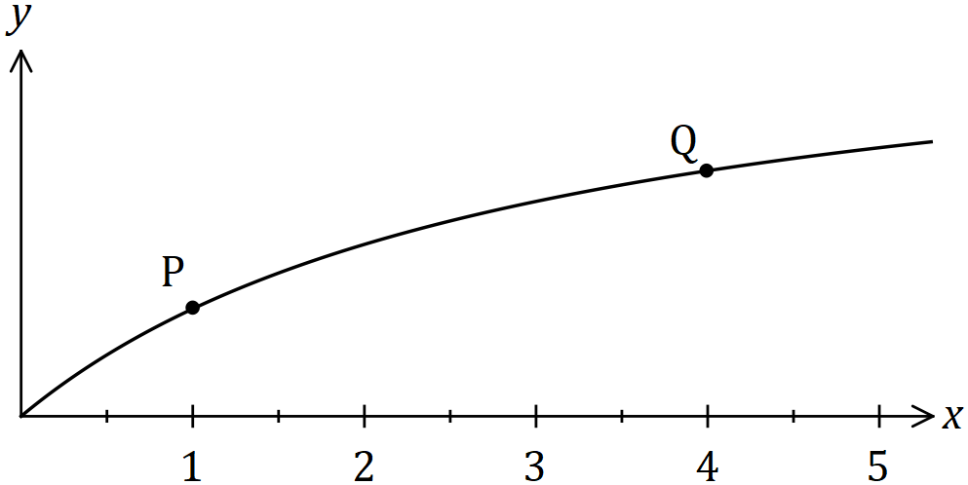

(a) Points $P$ and $Q$ lie on the curve with $x$-coordinates $1$ and $4$ respectively.

(i) Determine $f(1)$ and $f(4)$. (1 mark)

|  |
| --- |
| **Solution** |
| $$f\left(1\right)=\frac{1}{4}, f\left(4\right)=\frac{4}{7}$$ |
| **Specific behaviours** |
| ✓ both values correct |

(ii) Determine the gradient of the straight line through $P$ and $Q$. (2 marks)

|  |
| --- |
| **Solution** |
| $$m=\left(\frac{4}{7}-\frac{1}{4}\right)÷3=\left(\frac{16-7}{28}\right)÷3=\frac{3}{28}$$ |
| **Specific behaviours** |
| ✓ substitutes correctly into gradient formula  ✓ correct value |

(b) Use the formula $f^{'}\left(x\right)=\lim_{h→0}{\begin{matrix}f\left(x+h\right)-f(x) \\ \overline{ h }\end{matrix}}$ to determine the gradient of the curve at $P$.

(5 marks)

|  |
| --- |
| **Solution** |
| $$f^{'}\left(1\right)=\lim_{h→0}⁡\frac{f\left(1+h\right)-f\left(1\right)}{h} \\ =\lim_{h→0}\left(\frac{1+h}{4+h}-\frac{1}{4}\right)÷h \\ =\lim_{h→0}\left(\frac{4+4h-4-h}{4(4+h)}\right)÷h \\ =\lim_{h→0}\frac{3}{16+4h} \\ =\frac{3}{16}$$ |
| **Specific behaviours** |
| ✓ indicates that $f'(1)$ is required  ✓ substitutes function into quotient  ✓ correctly combines difference of fractions  ✓ eliminates division by $h$ ✓ evaluates limit |

Supplementary page

Question number: _________

© 2018 WA Exam Papers. Kennedy Baptist College has a non-exclusive licence to copy and communicate this document for non-commercial, educational use within the school. No other copying, communication or use is permitted without the express written permission of WA Exam Papers. SN245-122-2.